INTRODUCTION:
Chronic Kidney Disease refers to the kidneys' inability to fulfil their normal blood filtration role and other functions (CKD). The term "chronic" refers to the progressive deterioration of kidney cells over time. This is a severe renal failure in which the kidney no longer filters blood and there is a significant fluid accumulation in the body. This causes an abnormally high level of potassium and calcium salts in the body. High quantities of these salts in the body cause a variety of additional problems. The primary function of the kidneys is to filter excess water and wastes from the blood. This mechanism must work properly to balance the salts and minerals in our bodies. The proper salt balance is required blood pressure, activate hormones, red blood concentration causes bone problems cystic women. CKD cause sudden sickness allergy to specific medications. Acute is the term this condition.
SKILLS REQUIRED:
Python, Python Web Frame Works, Python For Data Visualization, Data Pre-processing Techniques, Machine Learning, IBM Cloud, IBM Watson Studio, Python-Flask
ARCHITECTURE:
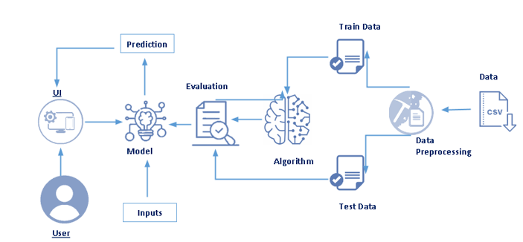
LITERATURE SURVEY:

Identification and Prediction of Chronic Diseases Using Machine learning Approach

Department of Computer Science, College of Science and Arts in Qurayyat, Jouf University, Sakakah, Saudi Arabia
humans face various diseases due to the current environmental condition and their living habits. 'e identification and prediction of such diseases at their earlier stages are much important, so as to prevent the extremity of it. It is difficult for doctors to manually identify the diseases accurately most of the time. The goal is to identify and predict the patients with more common chronic illnesses. It could be achieved by using a cutting-edge machine learning technique to ensure that this categorization reliably identifies persons with chronic diseases. Data mining plays a critical role in disease prediction. This proposed system offers a broad disease prognosis based on patient’s symptoms by using the machine learning algorithms such as convolutional neural network (CNN) for automatic feature extraction and disease prediction and K-nearest neighbor (KNN) for distance calculation to find the exact match in the data set and the final disease prediction outcome. A collection of disease symptoms has been performed for the preparation of the data set along with the person’s living habits, and details related to doctor consultations are taken into account in this general disease prediction. Finally, a comparative study of the proposed system with various algorithms such as Na¨ıve Bayes, decision tree, and logistic regression has been demonstrated .

Applications of Machine Learning Predictive Models in the Chronic Disease Diagnosis

Gopi Battineni 1,* , Getu Gamo Sagaro 1 , Nalini Chinatalapudi 1 and Francesco Amenta 1,2 1 Center for Telemedicine and Tele pharmacy, School of Medicinal and Health Sciences Products, University of Camerino, Via Madonna Della carceri 9, 62032 Camerino, Italy; getugamo.sagaro@unicam.it (G.G.S.); nalini.chintalapudi@unicam.it (N.C.); francesco.amenta@unicam.it (F.A.) 2 Research Department, International Medical Radio Center Foundation (C.I.R.M.), 00144 Roma, Italy.
.Chronic diseases (CDs) are responsible for a major portion of global health costs. Patients who suffer from these diseases need lifelong treatment. Nowadays, predictive models are frequently applied in the diagnosis and forecasting of these diseases. The state-of-the-art approaches that encompass ML models in the primary diagnosis of CD is reviewed. 22 studies were selected to present all modeling methods in a precise way that explains CD diagnosis and usage models of individual pathologies with associated strengths and limitations. This outcomes suggest that there are no standard methods to determine the best approach in real-time clinical practice since each method has its advantages and disadvantages. Among the methods considered, support vector machines (SVM), logistic regression (LR), clustering were the most commonly used. These models are highly applicable in classification, and diagnosis of CD and are expected to become more important in medical practice in the near future.

A method to predict diagnostic codes of chronic disease using Machine learning techniques

Dr. Deepa Gupta, Khare, S., and Aggarwal, A., “A method to predict diagnostic codes for chronic diseases using machine learning techniques”, in 2016 International Conference on Computing, Communication and Automation (ICCCA), 2016.
Healthcare in simplest form is all about diagnosis and prevention of disease or treatment of any injury by a medical practitioner. It plays an important role in providing quality life for the society. The concern is how to provide better service with less expensive therapeutically equivalent alternatives. Machine Learning techniques (ML) help in achieving this goal. Healthcare has various categories of data like clinical data, claims data, drugs data and hospital data. The focusshould be on clinical and claims data for studying 11 chronic diseases such as kidney disease, osteoporosis, arthritis etc. using the claims data. The correlation between the chronic diseases and the corresponding diagnostic tests is analyzed, by using ML techniques. An effective conclusion on various diagnostics for each chronic disease is made, keeping in mind the clinical relevance.

Chronicle Disease Diagnosis using Machine Learning

Shweta Ganiger School of Computer Science & Engineering KLE Technological University
Hubbli, Karnataka, India Shweta.b.ganiger@gmail.com K.M.M.Rajashekharaiah School of Computer Science & Engineering KLE Technological University, Hubbli, Karnataka, India.
As the chronicle disease is long lasting diseases, it takes long period to diagnosis. The chronicle disease is a threatening disease in all over the world, its cost more to diagnosis, as some of the chronicle diseases are unable to diagnose, the patient has to suffer throughout his lifetime. This kind disease data are available hugely in medical field, to make easier for healthcare system the data mining approaches are applied. Five chronicle dataset are taken and the machine learning approaches are applied, the machine learning algorithms such as decision tree, random forest, and the support vector machine are applied and the predicted whether the patient is suffering from disease. The chronicle disease such as heart disease, liver disease, diabetes, disease dataset are retrieved from the open source, and applied the data mining process to all the dataset. As we get the result by comparing all algorithms performance on all dataset the random forest predicts with high accuracy.
As per agile methodology we have various phases in our project
- Project Design and Planning Phase

- Project Development Phase

- Train the Machine Learning model on IBM

Project Design and Planning Phase:
In this project Design and Planning phase we have
- Ideation Phase
- Design Phase I
- Design Phase II
- Project Planning Phase

IDEATION PHASE:
During the ideation phase we have done problem definition, Empathy map canvas and Brainstorming and ideation process. Let us see in detail each activity
- PROBLEM STATEMENT:
• Non communicable illnesses are the leading cause of early death, and CKD is the leading non communicable disease.
• Chronic Kidney Disease is a major concern for the global health care system.
• People with CKD must focus on implementing proven, cost-effective therapies to as many people as possible while taking into consideration restricted needs, human and financial resources.
• Chronic kidney disease (CKD) is now wreaking havoc on society and is spreading at an alarming rate.
• Recent research suggests that some of the negative outcomes can be avoided with early identification and treatment.
- EMPATHY MAP:

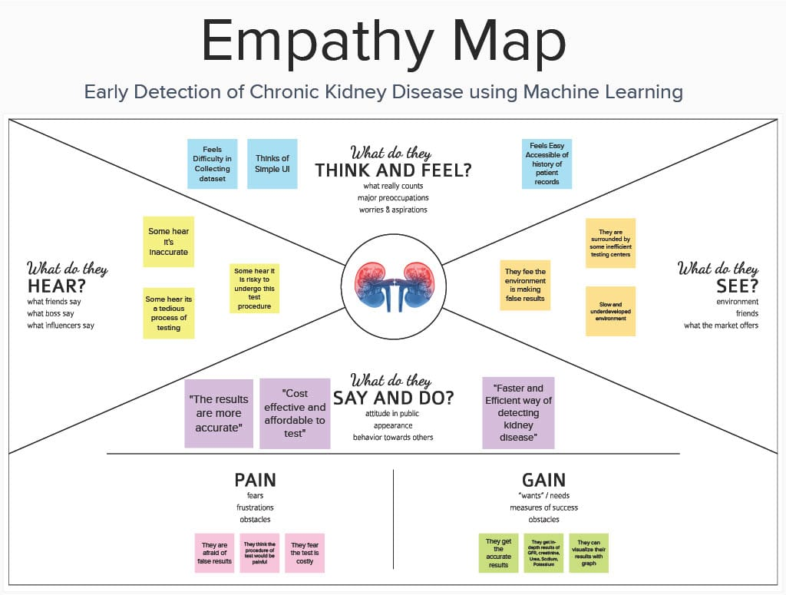

- BRAINSTORMING:

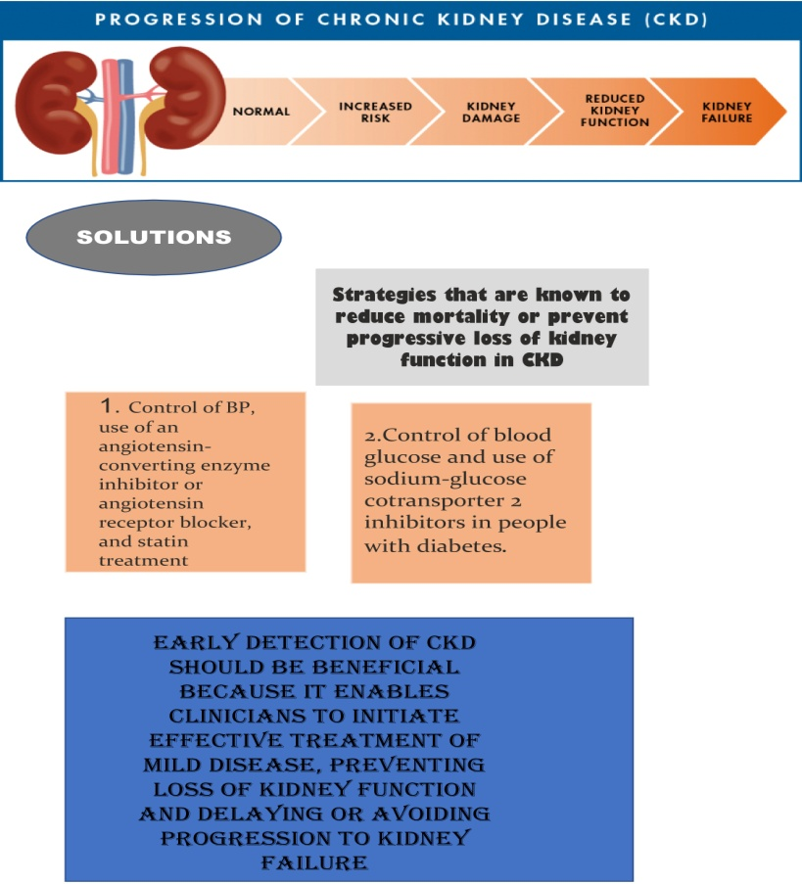

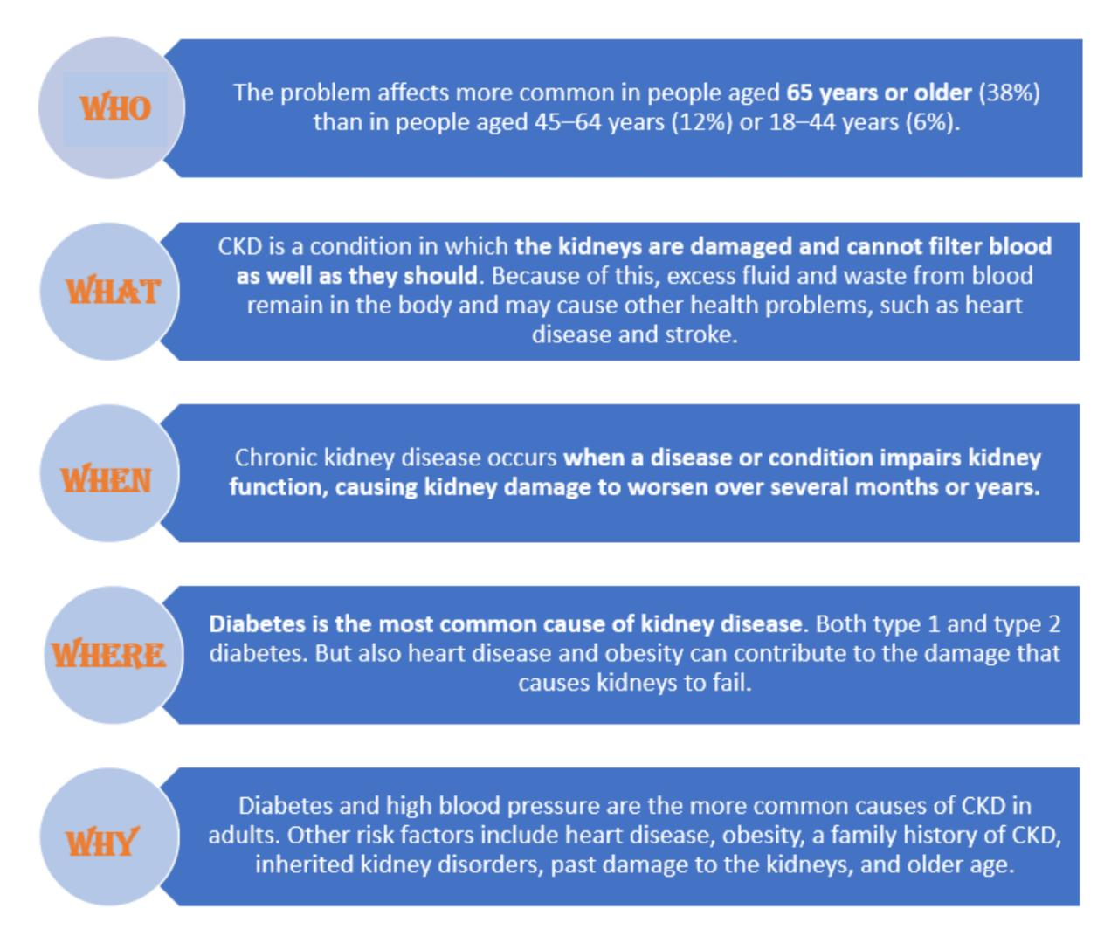

DESIGN PHASE I:

PROPOSED SOLUTION:
S.NO | PARAMETER | DESCRIPTION
1.
  Problem Statement (Problem to be solved)
  People suffering with chronic disease require a medium that prevents the development of disease into a severe condition by early detecting with the help of machine learning and giving treatment in a very effective way.
2.
  Idea / Solution description
   
  ➢ The initial stage is to perform pre-processing because some data sets are missing. Pre-processing involves cleaning of the dataset, scaling, and normalizing the numbers .
  ➢ The next step is to use dimensionality reduction to find the important features in the dataset and to remove that are not necessary.
  ➢ The next step is to use dimensionality reduction to find the important features in the dataset and to remove that are not necessary.
3.
  Novelty / Uniqueness
  An indicator of how well the kidney is working is the amount of a waste product called creatinine in the blood. By examining this data, early kidney disease can be identified by detecting deviations from the norm .
4.
  Social Impact / Customer Satisfaction
  The primary aim of this application is early prediction, and effective treatments may be able to prevent or delay the disease's progressing to an advanced state. That results you to stay healthy and fit.
5
  Business Model (Revenue Model)
  From business point of view it can collaborate with the healthcare sector to generate revenue from patients who come in for kidney disease diagnosis.
6. | Scalability of the Solution | It can be used for a variety of illnesses in addition to chronic disorders. The accuracy of many models can be compared in order to determine which is best.

- SOLUTION ARCHITECTURE:
PROJECT DESIGN PHASE II

CUSTOMER JOURNEY:
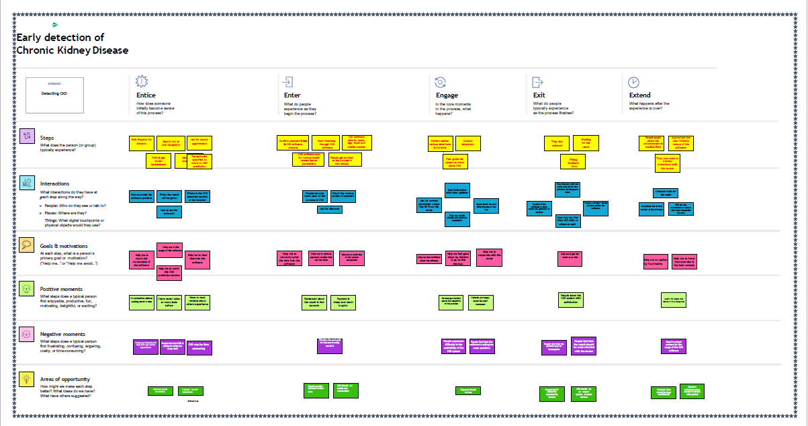
DATA FLOW DIAGRAM:
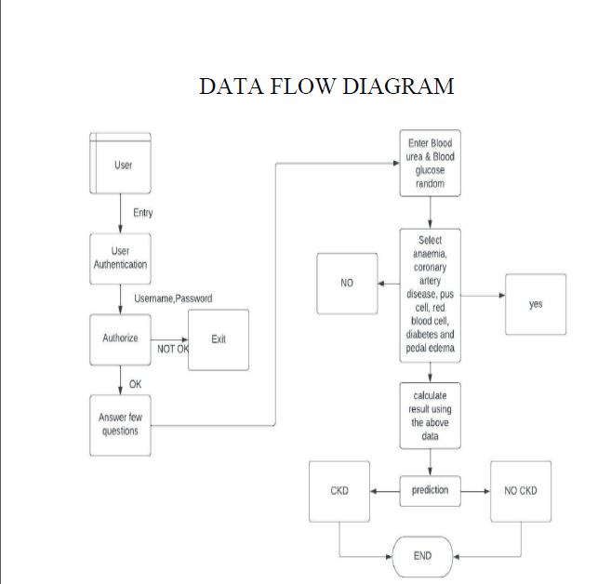
FUNCTIONAL REQUIREMENTS
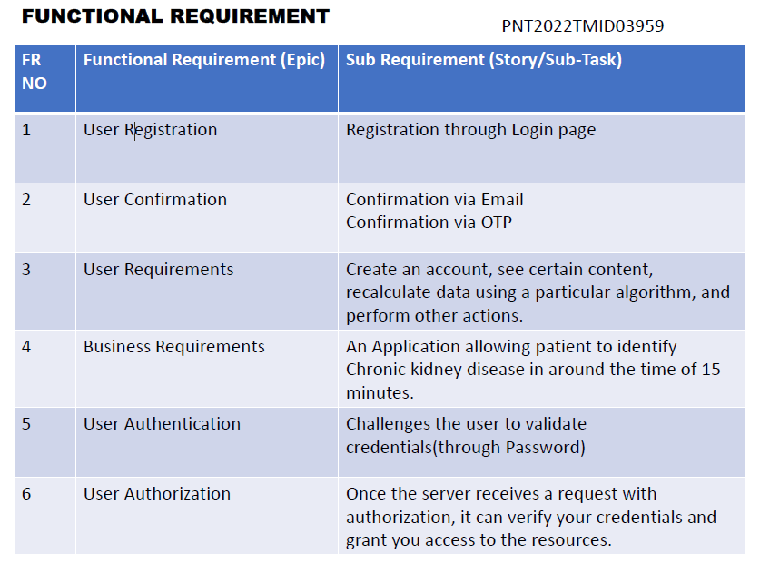
TECHNOLOGY ARCHITECTURE
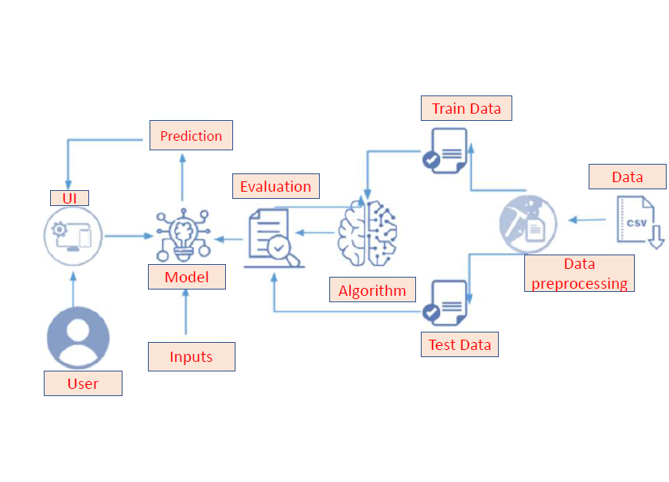
PROJECT PLANNING PHASE:
MILESTONE AND ACTIVITY LIST:
SPRINT PLAN DELIVERY:
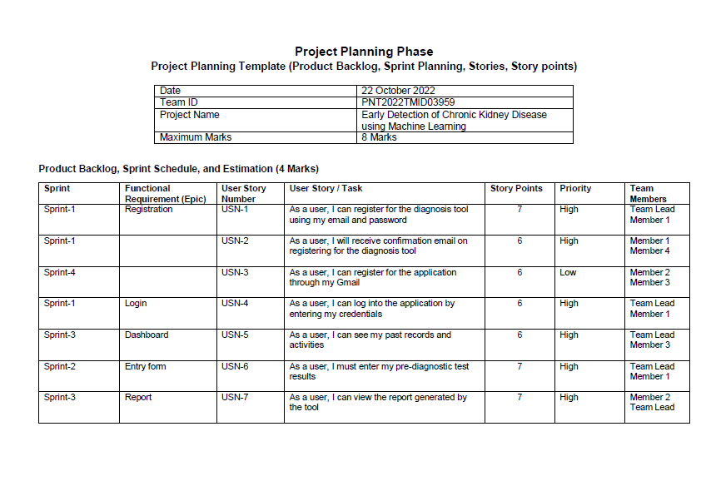
2.PROJECT DEVELOPMENT PHASE
During the Project Development Phase we have done four Sprints they are Sprint 1, Sprint 2, Sprint 3 and Sprint 4.In Agile product development, a sprint is a set period of time during which specific work has to be completed and made ready for review.
SPRINT 1:
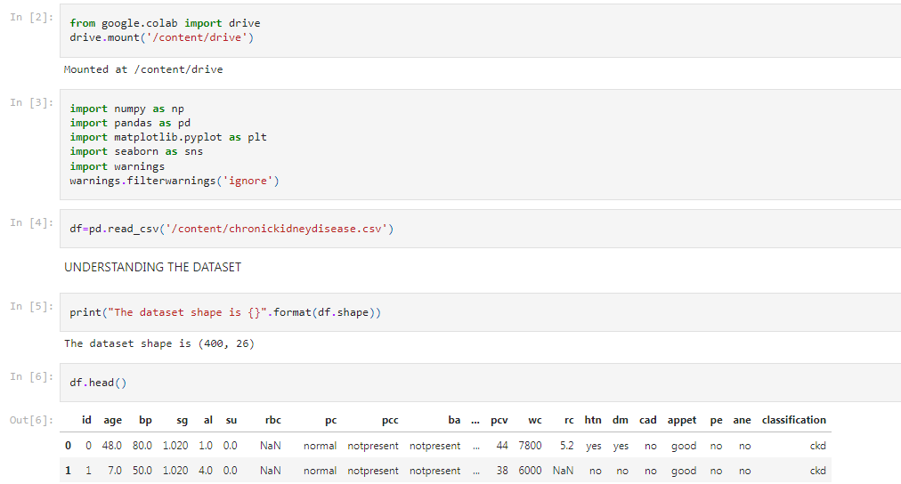
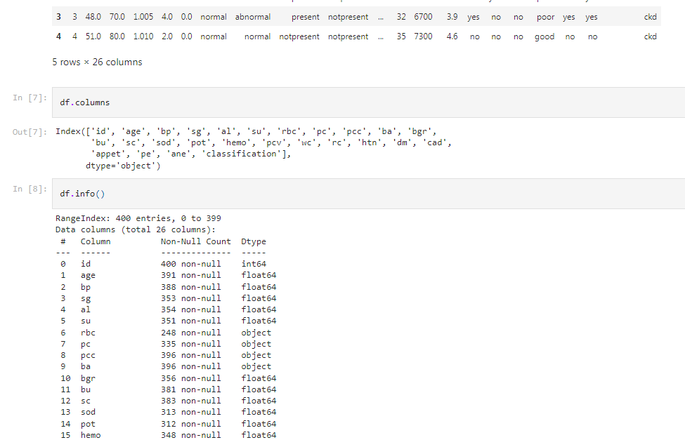

SPRINT 2
DASHBOARD:
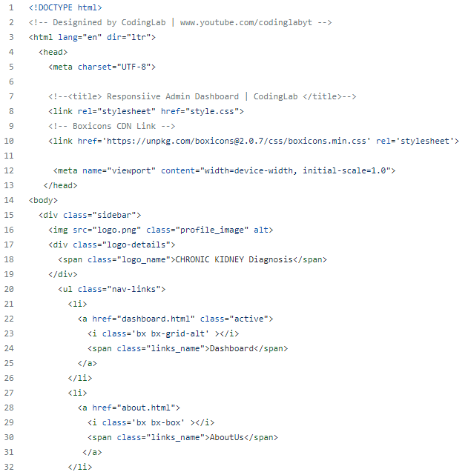

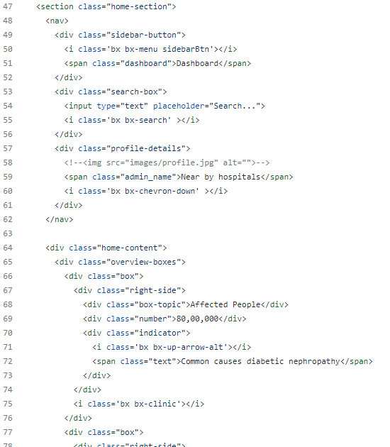
STYLE :
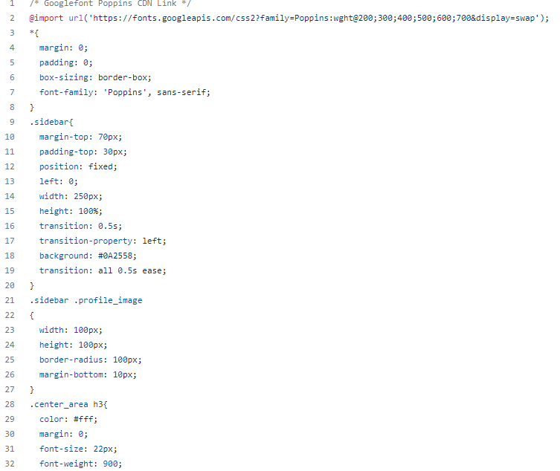
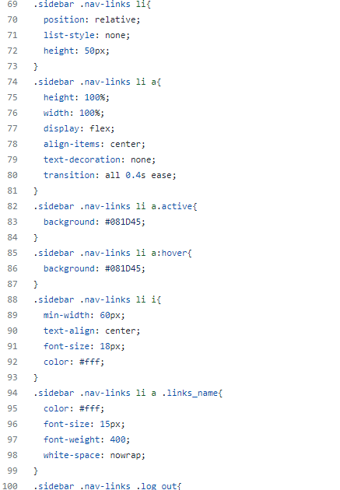

INDEX:
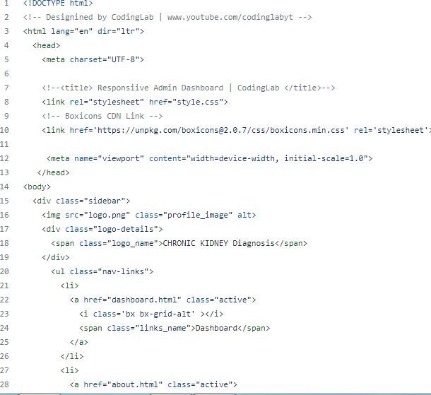

SPRINT 3:
INDEX:
<!DOCTYPE html>
<html>
<head>
<title>Early detection of chronic kidney disease</title>
<link rel="stylesheet" type="text/css" href="/static/stylesheets/homepage.css">
</head>
<body>
<div class="header">
<div class="inner-header">
<div class="logo">
<a href="https://checkup.com/">
<img src="https://checkup.com/assets/logo/checkup.png" >
</a>
</div>

<div class="header-link">
<a href="/Prediction"><button class="button">Prediction</button></a>
</div
<div class="header-link">
<a href="/Home"><button class="button">Home</button></a>
</div>
</div>
</div>
<div class="content">
<div class="banner-image">
<div class="inner-banner-image">
<div class="banner-content">
<h1>EARLY DETECTION OF CHRONIC KIDNEY DISAESE</h1>
</div>
</div>
</div>
</div>
</body>
</html>
PREDICTION:
<!doctype html>
<html>
<head>
<style>
h1{
background-color:purple;
color:white;
}
h2{
background-color:purple;
color:white;
}
</style>
<p><h1><center>Chronic Kidney Disease</center>
<center>A Machine Learning App build with Flask</center></h1></p>
</head>
<body>
<form>
<center><label for="urea">Enter blood_urea:</label><input type="textarea"></center><br>
<center><label for="urea">Enter blood Glucose Level:</label><input type="textarea"></center><br>
</form>
<center><form action="/action_page.php">
<label for="anaemic">Select anaemic or not:</label>
<select id="anaemic" name="anaemic">
<option value="yes">Yes</option>
<option value="no">No</option>
</select>
</form></center><br>
<center><form action="/action_page.php">
<label for="Coronary Artery">Select Coronary Artery disease or not:</label>
<select id="Coronary Artery" name="Coronary Artery">
<option value="yes">Yes</option>
<option value="no">No</option>
</select>
</form></center><br>
<center><form action="/action_page.php">
<label for="pus">Select pus cells or not:</label>
<select id="pus" name="pus">
<option value="yes">Yes</option>
<option value="no">No</option>
</select>
</form></center><br>
<center><form action="/action_page.php">
<label for="rbc">Select red blood cells level:</label>
<select id="rbc" name="rbc">
<option value="a">above 13 g/dl</option>
<option value="b">10-13 g/dl</option>
<option value="c">below 10 g/dl</option>
</select>
</form></center><br>
<center><form action="/action_page.php">
<label for="diabetes">Select diabetes mellituse or not:</label>
<select id="diabetes " name="diabetes">
<option value="yes">Yes</option>
<option value="no">No</option>
</select>
</form></center><br>
<center><form action="/action_page.php">
<label for="pedal edema">Select pedal edema or not:</label>
<select id="pedal edema" name="pedal edema">
<option value="yes">Yes</option>
<option value="no">No</option>
</select>
</form></center><br>
<a href="predictionreport.html"><form>
<center><input type="button" value="Predict"></center>
</form></a>
</body>
</html>
REPORT:
<!doctype html>
<html>
<head>
<style>
h1{
background-color:purple;
color:white;
}
h2{
color:red;
}
</style>
<p><h1><center>Chronic Kidney Disease</center>
<center>A Machine Learning App build with Flask</center></h1></p>
</head>
<br>
<body>
<center><h2>Prediction:Oops! You have Chronic Kidney Disease.</h2></center>
<center><img src="whaat-huh.jpg"></center>
</body>

SPRINT 4:
import numpy as np
import pandas as pd
from flask import Flask, request, render_template
import pickle as p
app=Flask(__name__)
import requests
# NOTE: you must manually set API_KEY below using information retrieved from your IBM Cloud account.
API_KEY = "8xKMa6emenCRK4FATPsRCiddtIIUM4Z6S-EiatGsqPU7"
token_response = requests.post('https://iam.cloud.ibm.com/identity/token', data={"apikey":
API_KEY, "grant_type": 'urn:ibm:params:oauth:grant-type:apikey'})
mltoken = token_response.json()["access_token"]
header = {'Content-Type': 'application/json', 'Authorization': 'Bearer ' + mltoken}
@app.route('/')
def HOME():
return render_template('home.html')
@app.route('/index')
def index():
return render_template('index.html')
@app.route('/predict',methods=['POST'])
def prediction():
form_value=request.form.values()
data=[]
for x in form_value:
data.append(pd.to_numeric(x).astype(float))

features_name=['age','blood_urea','blood glucose random','coronary_artery_disease',
'anemia','pus_cell','red_blood_cell','diabetesmellitus','pedal_edema']

payload_scoring = {"input_data": [{"fields": features_name, "values": [data]}]}
response_scoring = requests.post('https://us-south.ml.cloud.ibm.com/ml/v4/deployments/a0aba0b4-0d49-4acc-afd3-19c16a042590/predictions?version=2022-11-10', json=payload_scoring,
headers={'Authorization': 'Bearer ' + mltoken})
print("Scoring response")
prediction=response_scoring.json()
print(prediction)
output=prediction['predictions'][0]['values'][0][0]
if(output==0):
return render_template('index.html' , pred='Oops!! You have Kidney Chronic Disease. So, please concern a Doctor')
else:
return render_template('index.html' , pred='you are not affected by Chronic kidney Disease')
if __name__=='__main__':
app.run(debug=True)

TRAIN THE MODEL ON IBM:
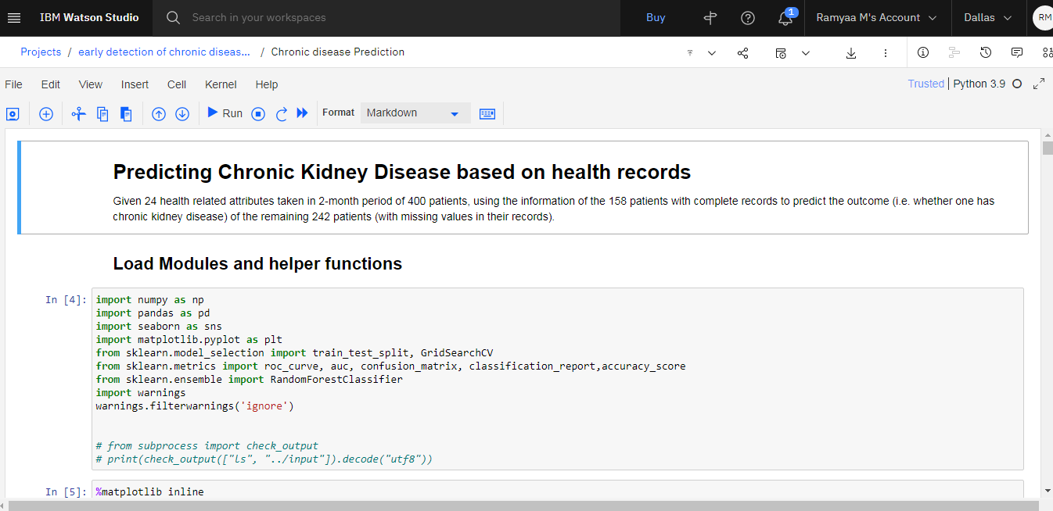
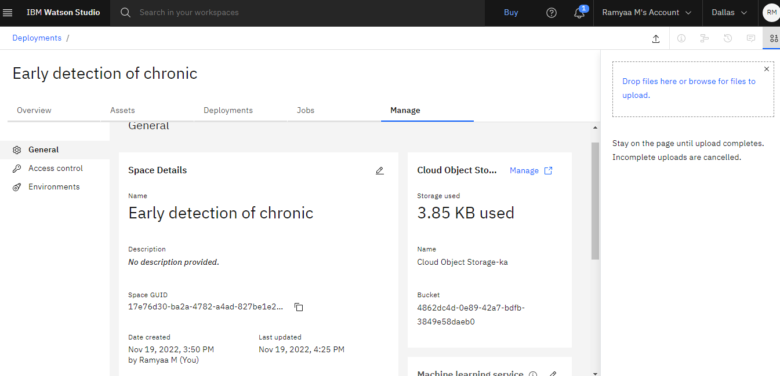

WEBPAGE RESULT:
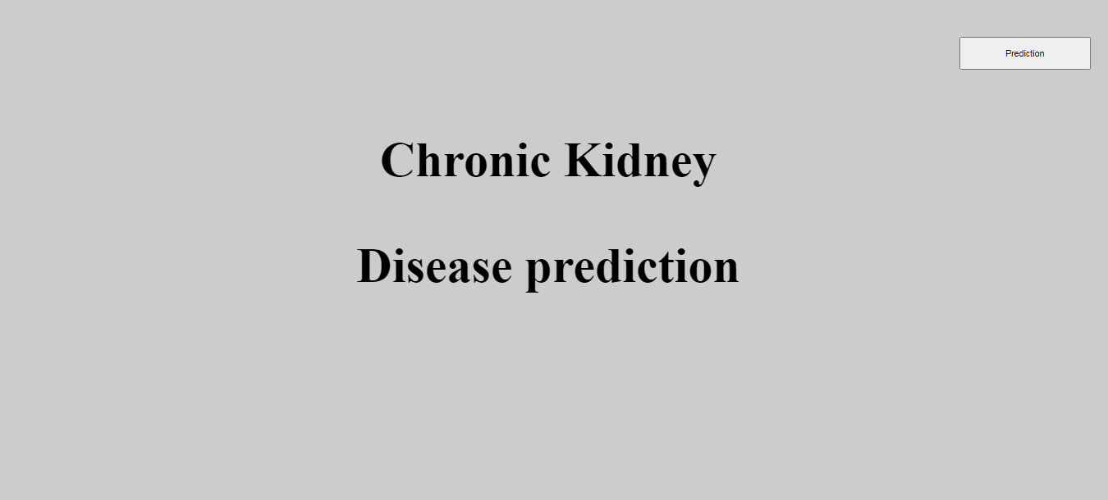
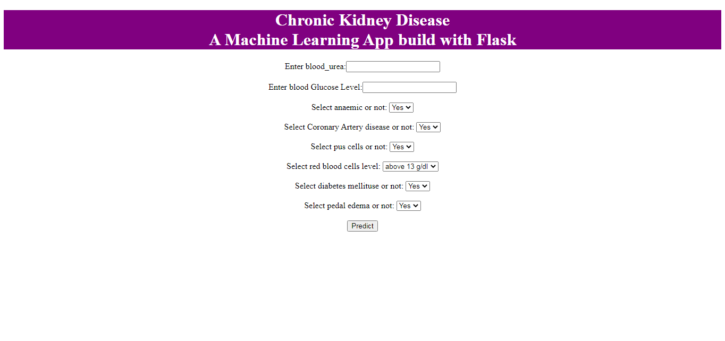
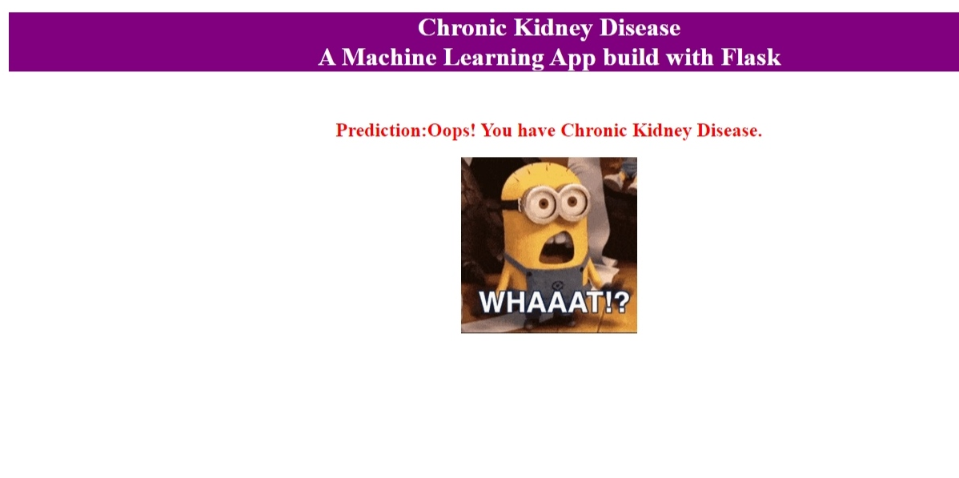
CONCLUSION:
This Project has helped team members to understand various concepts of Machine learning, Flask file, IBM cloud and Python notebook. This project can be scaled for usage in prediction of other chronic diseases which will help doctors in diagnosis of disease at an early stage thereby helping in early detection of various disease.
GITHUB LINK:
https://github.com/IBM-EPBL/IBM-Project-25374-1659960885

THANK YOU

